# API Response Evidence

Name: Add Customer details

Method: POST

URL: /api/rewards/customers

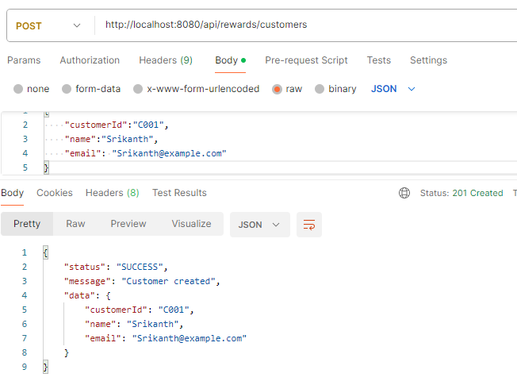

Name: Add Transactions

Method: POST

URL: /api/rewards/transactions

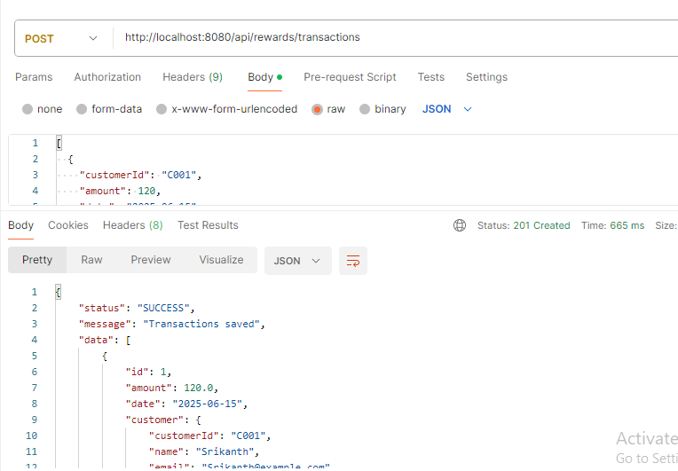

Name: Get customer Rewards

Method: GET

URL: /api/rewards/{CustomerId}

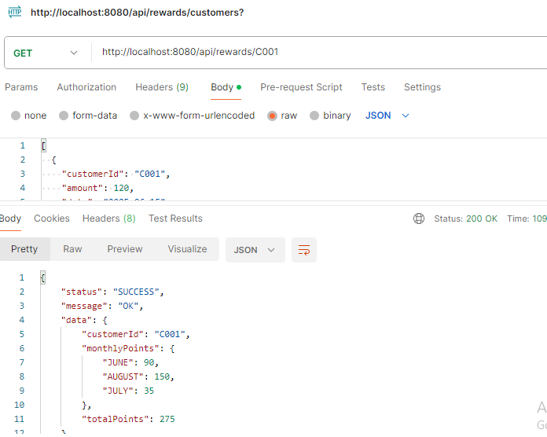

Junit test cases:

